| Please choose a lesson, or type 0 to return to course menu.

1: Principles of Analytic Graphs 2: Exploratory Graphs 3: Graphics Devices in R

4: Plotting Systems 5: Base Plotting System 6: Lattice Plotting System

7: Working with Colors 8: GGPlot2 Part1 9: GGPlot2 Part2

10: GGPlot2 Extras 11: Hierarchical Clustering 12: K Means Clustering

13: Dimension Reduction 14: Clustering Example 15: CaseStudy

Selection: 15

| | 0%

| CaseStudy. (Slides for this and other Data Science courses may be found at github

| https://github.com/DataScienceSpecialization/courses/. If you care to use them, they must be downloaded as a zip file and

| viewed locally. This lesson corresponds to 04_ExploratoryAnalysis/CaseStudy.)

...

|= | 1%

| In this lesson we'll apply some of the techniques we learned in this course to study air pollution data, specifically

| particulate matter (we'll call it pm25 sometimes), collected by the U.S. Environmental Protection Agency. This website

| https://www.health.ny.gov/environmental/indoors/air/pmq_a.htm from New York State offers some basic information on this

| topic if you're interested.

...

|== | 2%

| Particulate matter (less than 2.5 microns in diameter) is a fancy name for dust, and breathing in dust might pose health

| hazards to the population. We'll study data from two years, 1999 (when monitoring of particulate matter started) and 2012.

| Our goal is to see if there's been a noticeable decline in this type of air pollution between these two years.

...

|==== | 3%

| We've read in 2 large zipped files for you using the R command read.table (which is smart enough to unzip the files). We

| stored the 1999 data in the array pm0 for you. Run the R command dim now to see its dimensions.

> dim(pm0)

[1] 117421 5

| Your dedication is inspiring!

|===== | 4%

| We see that pm0 has over 117000 lines, each containing 5 columns. In the original file, at the EPA website, each row had 28

| columns, but since we'll be using only a few of these, we've created and read in a somewhat smaller file. Run head on pm0

| now to see what the first few lines look like.

> head(pm0)

V1 V2 V3 V4 V5

1 1 27 1 19990103 NA

2 1 27 1 19990106 NA

3 1 27 1 19990109 NA

4 1 27 1 19990112 8.841

5 1 27 1 19990115 14.920

6 1 27 1 19990118 3.878

| Keep up the great work!

|====== | 5%

| We see there's some missing data, but we won't worry about that now. We also see that the column names, V1, V2, etc., are

| not informative. However, we know that the first line of the original file (a comment) explained what information the

| columns contained.

...

|======= | 6%

| We created the variable cnames containing the 28 column names of the original file. Take a look at the column names now.

> cnames

[1] "# RD|Action Code|State Code|County Code|Site ID|Parameter|POC|Sample Duration|Unit|Method|Date|Start Time|Sample Value|Null Data Code|Sampling Frequency|Monitor Protocol (MP) ID|Qualifier - 1|Qualifier - 2|Qualifier - 3|Qualifier - 4|Qualifier - 5|Qualifier - 6|Qualifier - 7|Qualifier - 8|Qualifier - 9|Qualifier - 10|Alternate Method Detectable Limit|Uncertainty"

| You nailed it! Good job!

|======== | 7%

| We see that the 28 column names look all jumbled together even though they're separated by "|" characters, so let's fix

| this. Reassign to cnames the output of a call to strsplit (string split) with 3 arguments. The first is cnames, the pipe

| symbol '|' is the second (use the quotation marks), and the third is the argument fixed set to TRUE. Try this now.

> cnames <- strsplit(cnames, '|', fixed = TRUE)

| You got it!

|========== | 8%

| The variable cnames now holds a list of the column headings. Take another look at the column names.

> cnames

[[1]]

[1] "# RD" "Action Code" "State Code"

[4] "County Code" "Site ID" "Parameter"

[7] "POC" "Sample Duration" "Unit"

[10] "Method" "Date" "Start Time"

[13] "Sample Value" "Null Data Code" "Sampling Frequency"

[16] "Monitor Protocol (MP) ID" "Qualifier - 1" "Qualifier - 2"

[19] "Qualifier - 3" "Qualifier - 4" "Qualifier - 5"

[22] "Qualifier - 6" "Qualifier - 7" "Qualifier - 8"

[25] "Qualifier - 9" "Qualifier - 10" "Alternate Method Detectable Limit"

[28] "Uncertainty"

| You are quite good my friend!

|=========== | 9%

| Nice, but we don't need all these. Assign to names(pm0) the output of a call to the function make.names with

| cnames[[1]][wcol] as the argument. The variable wcol holds the indices of the 5 columns we selected (from the 28) to use in

| this lesson, so those are the column names we'll need. As the name suggests, the function "makes syntactically valid

| names".

> names(pm0) <- make.names(cnames[[1]][wcol])

| Nice work!

|============ | 10%

| Now re-run head on pm0 now to see if the column names have been put in place.

> head(pm0)

State.Code County.Code Site.ID Date Sample.Value

1 1 27 1 19990103 NA

2 1 27 1 19990106 NA

3 1 27 1 19990109 NA

4 1 27 1 19990112 8.841

5 1 27 1 19990115 14.920

6 1 27 1 19990118 3.878

| You're the best!

|============= | 11%

| Now it's clearer what information each column of pm0 holds. The measurements of particulate matter (pm25) are in the column

| named Sample.Value. Assign this component of pm0 to the variable x0. Use the m$n notation.

> x0 <- pm0$Sample.Value

| You nailed it! Good job!

|============== | 12%

| Call the R command str with x0 as its argument to see x0's structure.

> str(x0)

num [1:117421] NA NA NA 8.84 14.92 ...

| Perseverance, that's the answer.

|================ | 13%

| We see that x0 is a numeric vector (of length 117000+) with at least the first 3 values missing. Exactly what percentage

| of values are missing in this vector? Use the R function mean with is.na(x0) as an argument to see what percentage of

| values are missing (NA) in x0.

> mean(is.na(x0))

[1] 0.1125608

| Nice work!

|================= | 14%

| So a little over 11% of the 117000+ are missing. We'll keep that in mind. Now let's start processing the 2012 data which we

| stored for you in the array pm1.

...

|================== | 15%

| We'll repeat what we did for pm0, except a little more efficiently. First assign the output of

| make.names(cnames[[1]][wcol]) to names(pm1).

> names(pm1) <- make.names(cnames[[1]][wcol])

| Keep up the great work!

|=================== | 16%

| Find the dimensions of pm1 with the command dim.

> dim(pm1)

[1] 1304287 5

| All that hard work is paying off!

|==================== | 18%

| Wow! Over 1.3 million entries. Particulate matter was first collected in 1999 so perhaps there weren't as many sensors

| collecting data then as in 2012 when the program was more mature. If you ran head on pm1 you'd see that it looks just like

| pm0. We'll move on though.

...

|====================== | 19%

| Create the variable x1 by assigning to it the Sample.Value component of pm1.

> x1 <- pm1$Sample.Value

| Perseverance, that's the answer.

|======================= | 20%

| Now let's see what percentage of values are missing in x1. As before, use the R function mean with is.na(x1) as an argument

| to find out.

> mean(is.na(x1))

[1] 0.05607125

| Excellent work!

|======================== | 21%

| So only 5.6% of the particulate matter measurements are missing. That's about half the percentage as in 1999.

...

|========================= | 22%

| Now let's look at summaries (using the summary command) for both datasets. First, x0.

> summary(x0)

Min. 1st Qu. Median Mean 3rd Qu. Max. NA's

0.00 7.20 11.50 13.74 17.90 157.10 13217

| You are quite good my friend!

|========================== | 23%

| The numbers in the vectors x0 and x1 represent measurements taken in micrograms per cubic meter. Now look at the summary of

| x1.

> summary(x1)

Min. 1st Qu. Median Mean 3rd Qu. Max. NA's

-10.00 4.00 7.63 9.14 12.00 909.00 73133

| That's a job well done!

|============================ | 24%

| We see that both the median and the mean of measured particulate matter have declined from 1999 to 2012. In fact, all of

| the measurements, except for the maximum and missing values (Max and NA's), have decreased. Even the Min has gone down from

| 0 to -10.00! We'll address what a negative measurment might mean a little later. Note that the Max has increased from 157

| in 1999 to 909 in 2012. This is quite high and might reflect an error in the table or malfunctions in some monitors.

...

|============================= | 25%

| Call the boxplot function with 2 arguments, x0 and x1.

> boxplot(x0, x1)

| You nailed it! Good job!

|============================== | 26%

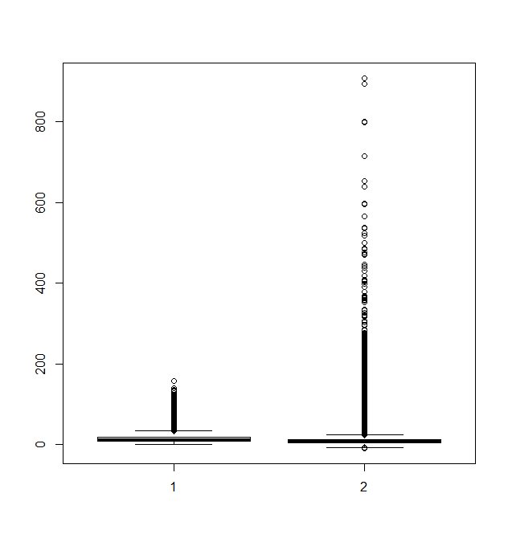

| Huh? Did somebody step on the boxes? It's hard to see what's going on here. There are so many values outside the boxes and

| the range of x1 is so big that the boxes are flattened. It might be more informative to call boxplot on the logs (base 10)

| of x0 and x1. Do this now using log10(x0) and log10(x1) as the 2 arguments.

> boxplot(log10(x0), log10(x1))

Warning messages:

1: In boxplot.default(log10(x0), log10(x1)) : NaNs produced

2: In bplt(at[i], wid = width[i], stats = z$stats[, i], out = z$out[z$group == :

Outlier (-Inf) in boxplot 1 is not drawn

3: In bplt(at[i], wid = width[i], stats = z$stats[, i], out = z$out[z$group == :

Outlier (-Inf) in boxplot 2 is not drawn

| That's correct!

|=============================== | 27%

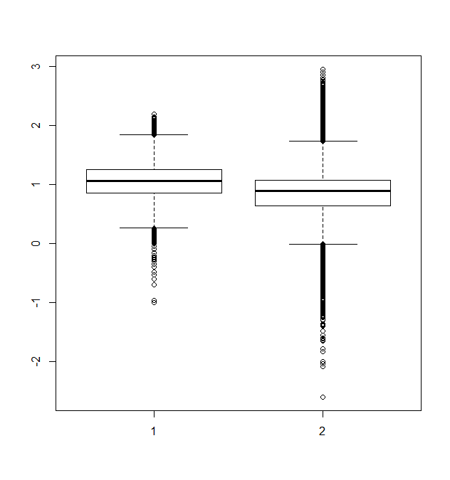

| A bonus! Not only do we get a better looking boxplot we also get some warnings from R in Red. These let us know that some

| values in x0 and x1 were "unloggable", no doubt the 0 (Min) we saw in the summary of x0 and the negative values we saw in

| the Min of the summary of x1.

...

|================================ | 28%

| From the boxplot (x0 on the left and x1 on the right), what can you say about the data?

1: The range of x0 is greater than the range of x1

2: The mean of x1 is less than the mean of x0

3: The median of x1 is less than the median of x0

4: The boxes are too small to interpret

Selection: 3

| You nailed it! Good job!

|================================= | 29%

| Let's return to the question of the negative values in x1. Let's count how many negative values there are. We'll do this in

| a few steps.

...

|=================================== | 30%

| First, form the vector negative by assigning to it the boolean x1<0.

> negative <- x1 < 0

| Keep working like that and you'll get there!

|==================================== | 31%

| Now run the R command sum with 2 arguments. The first is negative, and the second is na.rm set equal to TRUE. This tells

| sum to ignore the missing values in negative.

> sum(negative, na.rm = TRUE)

[1] 26474

| Excellent work!

|===================================== | 32%

| So there are over 26000 negative values. Sounds like a lot. Is it? Run the R command mean with same 2 arguments you just

| used with the call to sum. This will tell us a percentage.

> mean(negative, na.rm = TRUE)

[1] 0.0215034

| That's correct!

|====================================== | 33%

| We see that just 2% of the x1 values are negative. Perhaps that's a small enough percentage that we can ignore them. Before

| we ignore them, though, let's see if they occur during certain times of the year.

...

|======================================= | 34%

| First create the array dates by assigning to it the Date component of pm1. Remember to use the x$y notation.

> dates <- pm1$Date

| You nailed it! Good job!

|========================================= | 35%

| To see what dates looks like run the R command str on it.

> str(dates)

int [1:1304287] 20120101 20120104 20120107 20120110 20120113 20120116 20120119 20120122 20120125 20120128 ...

| Keep working like that and you'll get there!

|========================================== | 36%

| We see dates is a very long vector of integers. However, the format of the entries is hard to read. There's no separation

| between the year, month, and day. Reassign to dates the output of a call to as.Date with the 2 arguments

| as.character(dates) as the first argument and the string "%Y%m%d" as the second.

> dates <- as.Date(as.character(dates), "%Y%m%d")

| Your dedication is inspiring!

|=========================================== | 37%

| Now when you run head on dates you'll see the dates in a nicer format. Try this now.

> head(dates)

[1] "2012-01-01" "2012-01-04" "2012-01-07" "2012-01-10" "2012-01-13" "2012-01-16"

| Your dedication is inspiring!

|============================================ | 38%

| Let's plot a histogram of the months when the particulate matter measurements are negative. Run hist with 2 arguments. The

| first is dates[negative] and the second is the string "month".

> hist(dates[negative], "month")

| You are quite good my friend!

|============================================= | 39%

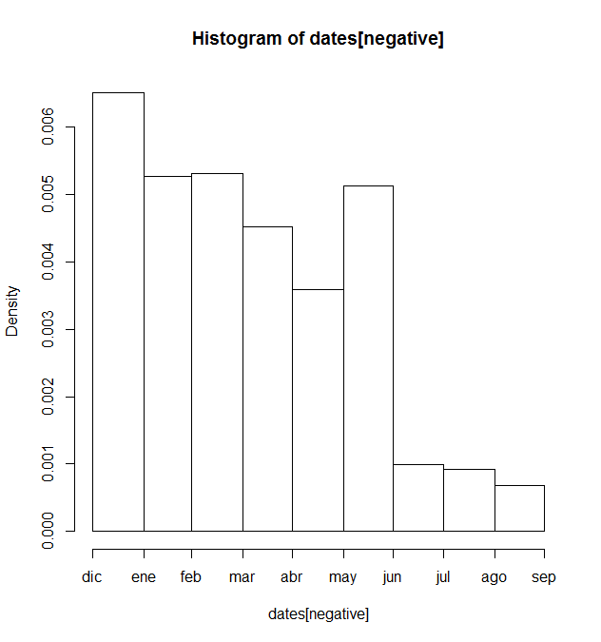

| We see the bulk of the negative measurements were taken in the winter months, with a spike in May. Not many of these

| negative measurements occurred in summer months. We can take a guess that because particulate measures tend to be low in

| winter and high in summer, coupled with the fact that higher densities are easier to measure, that measurement errors

| occurred when the values were low. For now we'll attribute these negative measurements to errors. Also, since they account

| for only 2% of the 2012 data, we'll ignore them.

...

|=============================================== | 40%

| Now we'll change focus a bit and instead of looking at all the monitors throughout the country and the data they recorded,

| we'll try to find one monitor that was taking measurements in both 1999 and 2012. This will allow us to control for

| different geographical and environmental variables that might have affected air quality in different areas. We'll narrow

| our search and look just at monitors in New York State.

...

|================================================ | 41%

| We subsetted off the New York State monitor identification data for 1999 and 2012 into 2 vectors, site0 and site1. Look at

| the structure of site0 now with the R command str.

> str(site0)

chr [1:33] "1.5" "1.12" "5.73" "5.80" "5.83" "5.110" "13.11" "27.1004" "29.2" "29.5" "29.1007" ...

| All that practice is paying off!

|================================================= | 42%

| We see that site0 (the IDs of monitors in New York State in 1999) is a vector of 33 strings, each of which has the form

| "x.y". We've created these from the county codes (the x portion of the string) and the monitor IDs (the y portion). If you

| ran str on site1 you'd see 18 similar values.

...

|================================================== | 43%

| Use the intersect command with site0 and site1 as arguments and put the result in the variable both.

> both <- intersect(site0, site1)

| You are amazing!

|=================================================== | 44%

| Take a look at both now.

> both

[1] "1.5" "1.12" "5.80" "13.11" "29.5" "31.3" "63.2008" "67.1015" "85.55" "101.3"

| Keep working like that and you'll get there!

|===================================================== | 45%

| We see that 10 monitors in New York State were active in both 1999 and 2012.

...

|====================================================== | 46%

| To save you some time and typing, we modified the data frames pm0 and pm1 slightly by adding to each of them a new

| component, county.site. This is just a concatenation of two original components County.Code and Site.ID. We did this to

| facilitate the next step which is to find out how many measurements were taken by the 10 New York monitors working in both

| of the years of interest. Run head on pm0 to see the first few entries now.

> head(pm0)

State.Code County.Code Site.ID Date Sample.Value county.site

1 1 27 1 19990103 NA 27.1

2 1 27 1 19990106 NA 27.1

3 1 27 1 19990109 NA 27.1

4 1 27 1 19990112 8.841 27.1

5 1 27 1 19990115 14.920 27.1

6 1 27 1 19990118 3.878 27.1

| You got it right!

|======================================================= | 47%

| Now pm0 and pm1 have 6 columns instead of 5, and the last column is a concatenation of two other columns, County and Site.

...

|======================================================== | 48%

| Now let's see how many measurements each of the 10 New York monitors that were active in both 1999 and 2012 took in those

| years. We'll create 2 subsets (one for each year), one of pm0 and the other of pm1.

...

|========================================================= | 49%

| The subsets will filter for 2 characteristics. The first is State.Code equal to 36 (the code for New York), and the second

| is that the county.site (the component we added) is in the vector both.

...

|=========================================================== | 51%

| First create the variable cnt0 by assigning to it the output of the R command subset, called with 2 arguments. The first is

| pm0, and the second is a boolean with the 2 conditions we just mentioned. Recall that the testing for equality in a boolean

| requires ==, intersection of 2 boolean conditions is denoted by & and membership by %in%.

> cnt0 <- subset(pm0, State.Code == 36 & county.site %in% both)

| All that practice is paying off!

|============================================================ | 52%

| Recall the last command with the up arrow, and create cnt1 (instead of cnt0). Remember to change pm0 to pm1. Everything

| else can stay the same.

> cnt1 <- subset(pm1, State.Code == 36 & county.site %in% both)

| That's correct!

|============================================================= | 53%

| Now run the command sapply(split(cnt0, cnt0$county.site), nrow). This will split cnt0 into several data frames according to

| county.site (that is, monitor IDs) and tell us how many measurements each monitor recorded.

> sapply(split(cnt0, cnt0$county.site), nrow)

1.12 1.5 101.3 13.11 29.5 31.3 5.80 63.2008 67.1015 85.55

61 122 152 61 61 183 61 122 122 7

| You nailed it! Good job!

|============================================================== | 54%

| Do the same for cnt1. (Recall your last command and change 2 occurrences of cnt0 to cnt1.)

> sapply(split(cnt1, cnt1$county.site), nrow)

1.12 1.5 101.3 13.11 29.5 31.3 5.80 63.2008 67.1015 85.55

31 64 31 31 33 15 31 30 31 31

| Keep up the great work!

|=============================================================== | 55%

| From the output of the 2 calls to sapply, which monitor is the only one whose number of measurements increased from 1999 to

| 2012?

1: 101.3

2: 63.2008

3: 85.55

4: 29.5

Selection: 3

| Perseverance, that's the answer.

|================================================================= | 56%

| We want to examine a monitor with a reasonable number of measurements so let's look at the monitor with ID 63.2008. Create

| a variable pm0sub which is the subset of cnt0 (this contains just New York data) which has County.Code equal to 63 and

| Site.ID 2008.

> pm0sub <- subset(cnt0, County.Code==63 & Site.ID==2008)

| You got it!

|================================================================== | 57%

| Now do the same for cnt1. Name this new variable pm1sub.

> pm1sub <- subset(cnt1, County.Code==63 & Site.ID==2008)

| Keep working like that and you'll get there!

|=================================================================== | 58%

| From the output of the 2 calls to sapply, how many rows will pm0sub have?

1: 122

2: 30

3: 183

4: 29

Selection: 1

| Keep up the great work!

|==================================================================== | 59%

| Now we'd like to compare the pm25 measurements of this particular monitor (63.2008) for the 2 years. First, create the

| vector x0sub by assigning to it the Sample.Value component of pm0sub.

> x0sub <- pm0sub$Sample.Value

| Keep working like that and you'll get there!

|===================================================================== | 60%

| Similarly, create x1sub from pm1sub.

> x1sub <- pm1sub$Sample.Value

| That's a job well done!

|======================================================================= | 61%

| We'd like to make our comparison visually so we'll have to create a time series of these pm25 measurements. First, create a

| dates0 variable by assigning to it the output of a call to as.Date. This will take 2 arguments. The first is a call to

| as.character with pm0sub$Date as the argument. The second is the format string "%Y%m%d".

> dates0 <- as.Date(as.character(pm0sub$Date), "%Y%m%d")

| You got it right!

|======================================================================== | 62%

| Do the same for the 2012 data. Specifically, create dates1 using pm1sub$Date as your input.

> dates1 <- as.Date(as.character(pm1sub$Date), "%Y%m%d")

| Keep up the great work!

|========================================================================= | 63%

| Now we'll plot these 2 time series in the same panel using the base plotting system. Call par with 2 arguments. The first

| is mfrow set equal to c(1,2). This will tell the system we're plotting 2 graphs in 1 row and 2 columns. The second argument

| will adjust the panel's margins. It is mar set to c(4,4,2,1).

> par(mfrow = c(1, 2), mar = c(4, 4, 2, 1))

| You are amazing!

|========================================================================== | 64%

| Call plot with the 3 arguments dates0, x0sub, and pch set to 20. The first two arguments are the x and y coordinates. This

| will show the pm25 values as functions of time.

> plot(dates0, x0sub, pch = 20)

| All that practice is paying off!

|=========================================================================== | 65%

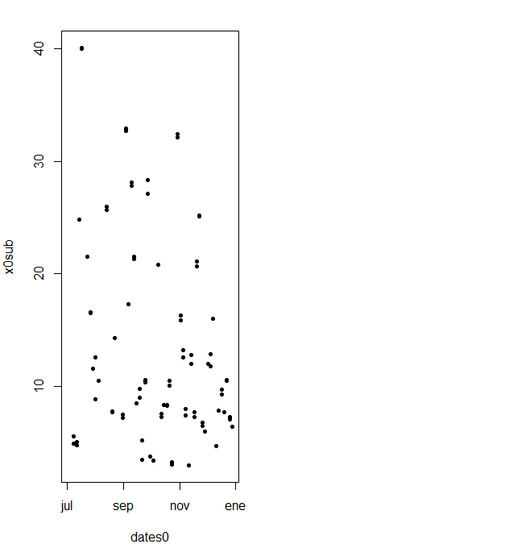

| Now we'll mark the median.

...

|============================================================================= | 66%

| Use abline to add a horizontal line at the median of the pm25 values. Make the line width 2 (lwd is the argument), and when

| you call median with x0sub, specify the argument na.rm to be TRUE.

> abline(h = median(x0sub, na.rm = TRUE),lwd=2)

| That's correct!

|============================================================================== | 67%

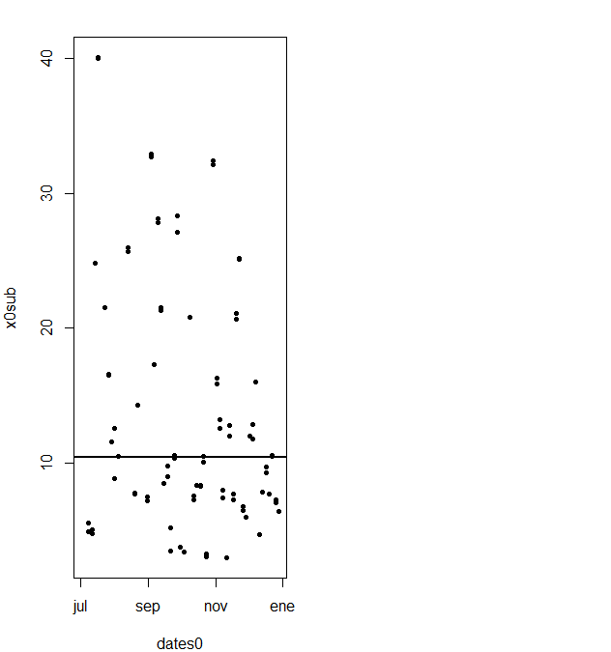

| Now we'll do the same for the 2012 data. Call plot with the 3 arguments dates1, x1sub, and pch set to 20.

> plot(dates1, x1sub, pch = 20)

| You are really on a roll!

|=============================================================================== | 68%

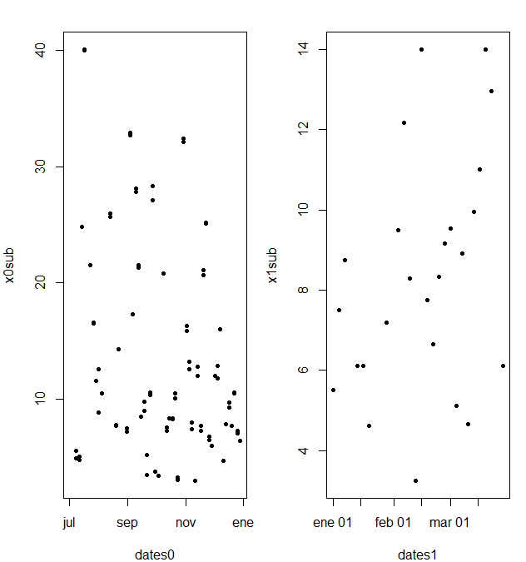

| As before, we'll mark the median of this 2012 data.

...

|================================================================================ | 69%

| Use abline to add a horizontal line at the median of the pm25 values. Make the line width 2 (lwd is the argument). Remember

| to specify the argument na.rm to be TRUE when you call median on x1sub.

> abline(h = median(x1sub, na.rm = TRUE),lwd=2)

| You are doing so well!

|================================================================================= | 70%

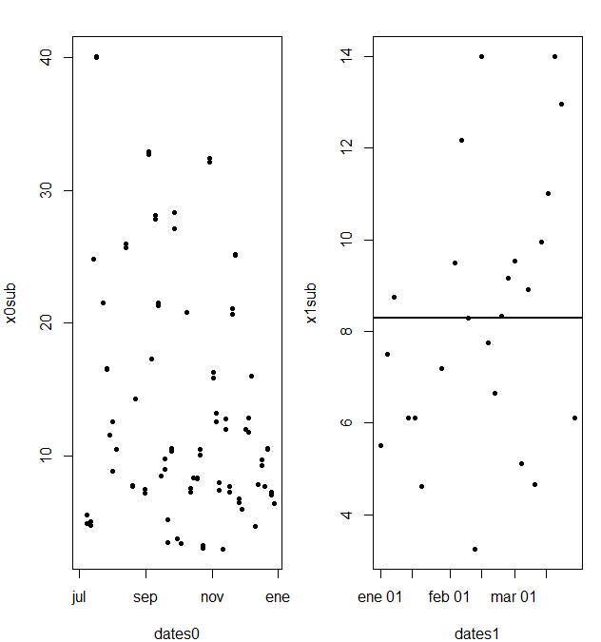

| Which median is larger - the one for 1999 or the one for 2012?

1: 1999

2: 2012

Selection: 1

| Your dedication is inspiring!

|=================================================================================== | 71%

| The picture makes it look like the median is higher for 2012 than 1999. Closer inspection shows that this isn't true. The

| median for 1999 is a little over 10 micrograms per cubic meter and for 2012 its a little over 8. The plots appear this way

| because the 1999 plot ....

1: shows different months than those in the 2012 plot

2: shows a bigger range of y values than the 2012 plot

3: displays more points than the 2012 plot

Selection: 2

| Excellent job!

|==================================================================================== | 72%

| The 1999 plot shows a much bigger range of pm25 values on the y axis, from below 10 to 40, while the 2012 pm25 values are

| much more restricted, from around 1 to 14. We should really plot the points of both datasets on the same range of values on

| the y axis. Create the variable rng by assigning to it the output of a call to the R command range with 3 arguments, x0sub,

| x1sub, and the boolean na.rm set to TRUE.

> rng <- range(x0sub, x1sub, na.rm = TRUE)

| That's correct!

|===================================================================================== | 73%

| Look at rng to see the values it spans.

> rng

[1] 3.0 40.1

| Keep working like that and you'll get there!

|====================================================================================== | 74%

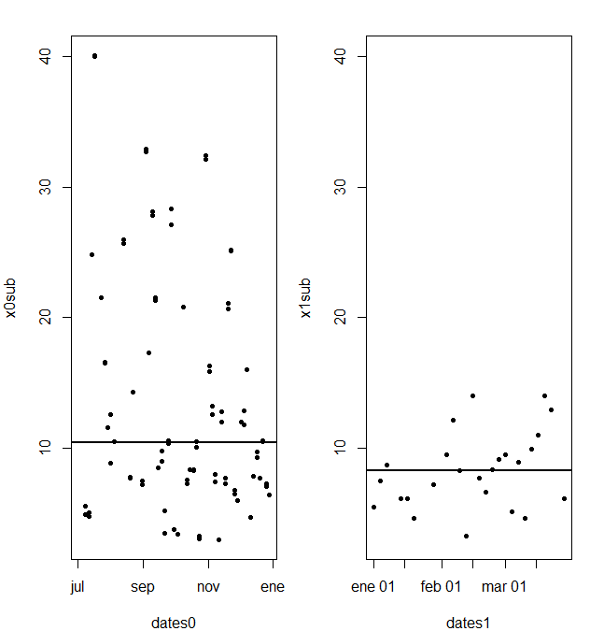

| Here a new figure we've created showing the two plots side by side with the same range of values on the y axis. We used the

| argument ylim set equal to rng in our 2 calls to plot. The improvement in the medians between 1999 and 2012 is now clear.

| Also notice that in 2012 there are no big values (above 15). This shows that not only is there a chronic improvement in air

| quality, but also there are fewer days with severe pollution.

...

|======================================================================================= | 75%

| The last avenue of this data we'll explore (and we'll do it quickly) concerns a comparison of all the states' mean

| pollution levels. This is important because the states are responsible for implementing the regulations set at the federal

| level by the EPA.

...

|======================================================================================== | 76%

| Let's first gather the mean (average measurement) for each state in 1999. Recall that the original data for this year was

| stored in pm0.

...

|========================================================================================== | 77%

| Create the vector mn0 with a call to the R command with using 2 arguments. The first is pm0. This is the data in which the

| second argument, an expression, will be evaluated. The second argument is a call to the function tapply. This call requires

| 4 arguments. Sample.Value and State.Code are the first two. We want to apply the function mean to Sample.Value, so mean is

| the third argument. The fourth is simply the boolean na.rm set to TRUE.

> mn0 <- with(pm0, tapply(Sample.Value, State.Code, mean, na.rm = TRUE))

| Your dedication is inspiring!

|=========================================================================================== | 78%

| Call the function str with mn0 as its argument to see what it looks like.

> str(mn0)

num [1:53(1d)] 19.96 6.67 10.8 15.68 17.66 ...

- attr(*, "dimnames")=List of 1

..$ : chr [1:53] "1" "2" "4" "5" ...

| You got it!

|============================================================================================ | 79%

| We see mn0 is a 53 long numerical vector. Why 53 if there are only 50 states? As it happens, pm25 measurements for the

| District of Columbia (Washington D.C), the Virgin Islands, and Puerto Rico are included in this data. They are coded as 11,

| 72, and 78 respectively.

...

|============================================================================================= | 80%

| Recall your command creating mn0 and change it to create mn1 using pm1 as the first input to the call to with.

> mn1 <- with(pm1, tapply(Sample.Value, State.Code, mean, na.rm = TRUE))

| Perseverance, that's the answer.

|============================================================================================== | 81%

| For fun, call the function str with mn1 as its argument.

> str(mn1)

num [1:52(1d)] 10.13 4.75 8.61 10.56 9.28 ...

- attr(*, "dimnames")=List of 1

..$ : chr [1:52] "1" "2" "4" "5" ...

| Perseverance, that's the answer.

|================================================================================================ | 82%

| So mn1 has only 52 entries, rather than 53. We checked. There are no entries for the Virgin Islands in 2012. Call summary

| now with mn0 as its input.

> summary(mn0)

Min. 1st Qu. Median Mean 3rd Qu. Max.

4.862 9.519 12.310 12.410 15.640 19.960

| That's correct!

|================================================================================================= | 84%

| Now call summary with mn1 as its input so we can compare the two years.

> summary(mn1)

Min. 1st Qu. Median Mean 3rd Qu. Max.

4.006 7.355 8.729 8.759 10.610 11.990

| You got it!

|================================================================================================== | 85%

| We see that in all 6 entries, the 2012 numbers are less than those in 1999. Now we'll create 2 new dataframes containing

| just the state names and their mean measurements for each year. First, we'll do this for 1999. Create the data frame d0 by

| calling the function data.frame with 2 arguments. The first is state set equal to names(mn0), and the second is mean set

| equal to mn0.

> d0 <- data.frame(state = names(mn0), mean = mn0)

| Keep up the great work!

|=================================================================================================== | 86%

| Recall the last command and create d1 instead of d0 using the 2012 data. (There'll be 3 changes of 0 to 1.)

> d1 <- data.frame(state = names(mn1), mean = mn1)

| All that practice is paying off!

|==================================================================================================== | 87%

| Create the array mrg by calling the R command merge with 3 arguments, d0, d1, and the argument by set equal to the string

| "state".

> mrg <- merge(d0, d1, by = "state")

| You are doing so well!

|====================================================================================================== | 88%

| Run dim with mrg as its argument to see how big it is.

> dim(mrg)

[1] 52 3

| All that hard work is paying off!

|======================================================================================================= | 89%

| We see merge has 52 rows and 3 columns. Since the Virgin Island data was missing from d1, it is excluded from mrg. Look at

| the first few entries of mrg using the head command.

> head(mrg)

state mean.x mean.y

1 1 19.956391 10.126190

2 10 14.492895 11.236059

3 11 15.786507 11.991697

4 12 11.137139 8.239690

5 13 19.943240 11.321364

6 15 4.861821 8.749336

| You are doing so well!

|======================================================================================================== | 90%

| Each row of mrg has 3 entries - a state identified by number, a state mean for 1999 (mean.x), and a state mean for 2012

| (mean.y).

...

|========================================================================================================= | 91%

| Now we'll plot the data to see how the state means changed between the 2 years. First we'll plot the 1999 data in a single

| column at x=1. The y values for the points will be the state means. Again, we'll use the R command with so we don't have to

| keep typing mrg as the data environment in which to evaluate the second argument, the call to plot. We've already reset the

| graphical parameters for you.

...

|========================================================================================================== | 92%

| For the first column of points, call with with 2 arguments. The first is mrg, and the second is the call to plot with 3

| arguments. The first of these is rep(1,52). This tells the plot routine that the x coordinates for all 52 points are 1. The

| second argument is the second column of mrg or mrg[,2] which holds the 1999 data. The third argument is the range of x

| values we want, namely xlim set to c(.5,2.5). This works since we'll be plotting 2 columns of points, one at x=1 and the

| other at x=2.

> with(mrg, plot(rep(1, 52), mrg[, 2], xlim = c(.5, 2.5)))

| Keep up the great work!

|============================================================================================================ | 93%

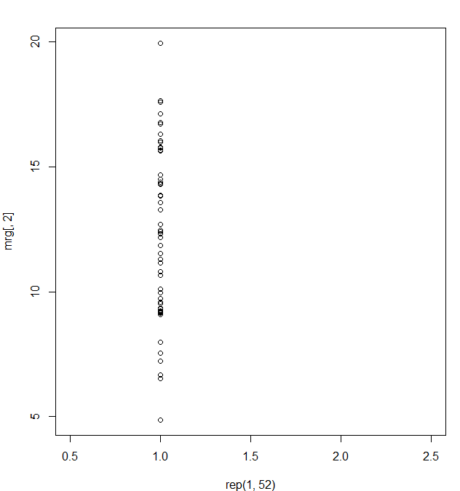

| We see a column of points at x=1 which represent the 1999 state means. For the second column of points, again call with

| with 2 arguments. As before, the first is mrg. The second, however, is a call to the function points with 2 arguments. We

| need to do this since we're adding points to an already existing plot. The first argument to points is the set of x values,

| rep(2,52). The second argument is the set of y values, mrg[,3]. Of course, this is the third column of mrg. (We don't need

| to specify the range of x values again.)

> with(mrg, points(rep(2, 52), mrg[, 3]))

| That's correct!

|============================================================================================================= | 94%

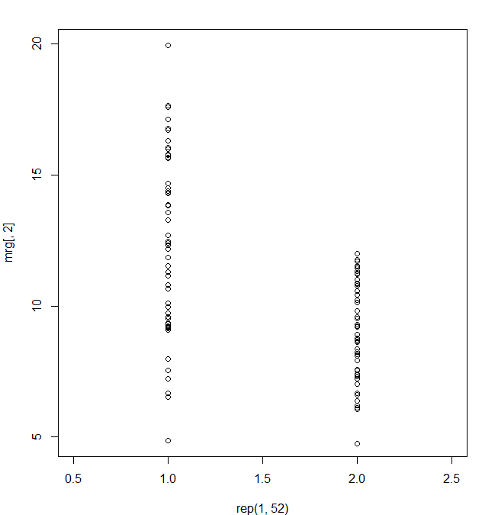

| We see a shorter column of points at x=2. Now let's connect the dots. Use the R function segments with 4 arguments. The

| first 2 are the x and y coordinates of the 1999 points and the last 2 are the x and y coordinates of the 2012 points. As in

| the previous calls specify the x coordinates with calls to rep and the y coordinates with references to the appropriate

| columns of mrg.

> segments(rep(1, 52), mrg[, 2], rep(2, 52), mrg[, 3])

| That's the answer I was looking for.

|============================================================================================================== | 95%

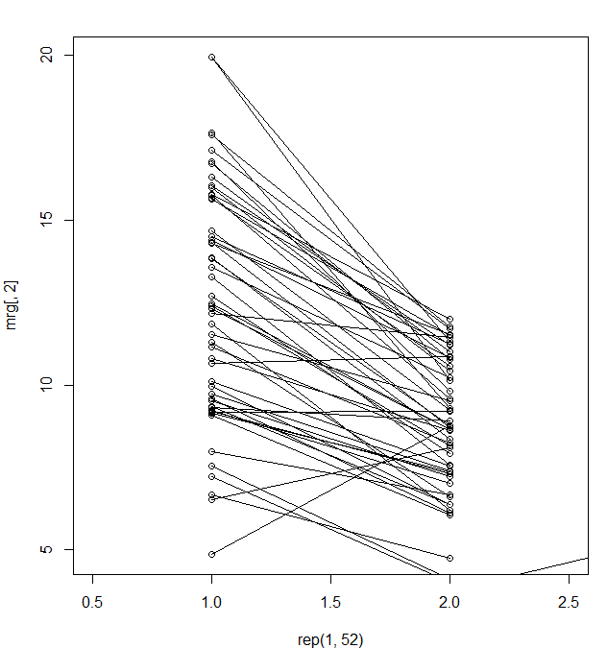

| We see from the plot that the vast majority of states have indeed improved their particulate matter counts so the general

| trend is downward. There are a few exceptions. (The topmost point in the 1999 column is actually two points that had very

| close measurements.)

...

|=============================================================================================================== | 96%

| For fun, let's see which states had higher means in 2012 than in 1999. Just use the mrg[mrg$mean.x < mrg$mean.y, ] notation

| to find the rows of mrg with this particulate property.

> mrg[mrg$mean.x < mrg$mean.y, ]

state mean.x mean.y

6 15 4.861821 8.749336

23 31 9.167770 9.207489

27 35 6.511285 8.089755

33 40 10.657617 10.849870

| You are really on a roll!

|================================================================================================================ | 97%

| Only 4 states had worse pollution averages, and 2 of these had means that were very close. If you want to see which states

| (15, 31, 35, and 40) these are, you can check out this website http://www.epa.gov/envirofw/html/codes/state.html to decode

| the state codes.

...

|================================================================================================================== | 98%

| This concludes the lesson, comparing air pollution data from two years in different ways. First, we looked at measures of

| the entire set of monitors, then we compared the two measures from a particular monitor, and finally, we looked at the mean

| measures of the individual states.

...

|=================================================================================================================== | 99%

| Congratulations! We hope you enjoyed this particulate lesson.

...

|====================================================================================================================| 100%